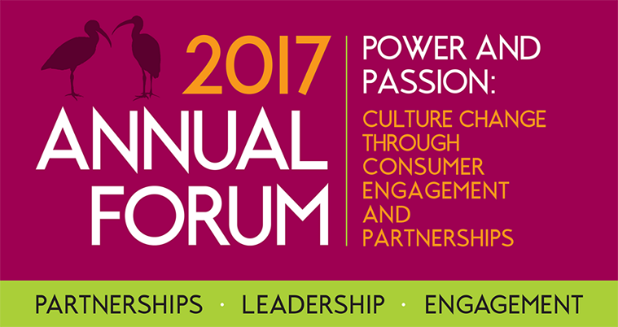
Call for Abstracts NOW OPEN
Power and Passion:
Culture change through consumer engagement and partnerships
Date: Thursday 18 May 2017 Time: 8.30am – 5.00pm
Venue: Rydges Southbank Townsville, 23 Palmer Street, Townsville Qld 4810
Health Consumers Queensland look forward to receiving your abstracts to present at our 2017 Annual Forum. We invite health consumers and carers, Queensland health staff and services, Primary Health Networks, community members and community organisations to share your stories and experiences through presentations.
A healthcare organisation’s culture – ‘the way we do things around here’ – shapes the behaviour of everyone in the organisation and so affects the quality of care that together they provide. (NHS, UK.)
Abstract Submission details
- Abstracts must be submitted using this template by 5pm Tuesday 10 January 2017
- We encourage Queensland based, joint presentations by a staff member and/or consumer/carer
- Presentations will be 30 minutes duration, including question and answer discussion time
- Abstracts will be selected by a reference group comprising Health Consumers Queensland staff and consumer representatives
- Limited travel assistance is available for successful consumer applicants, however it is expected that staff (and ideally also consumer) speaker travel be covered by the local health service
Kay Dates and Deadlines
Call for Abstracts Open | Tuesday 15 November 2016
Expression of Interest open for Annual Forum Reference Group | Monday 21 November 2016
EOI Annual Forum Reference Group Close | Friday 16 December 2016
Call for Abstracts Close | Tuesday 10 January 2017
First Annual Forum Reference Group Meeting | Late January TBA, 2017
Call for Abstract Presenters notified | Friday 10 February 2017
Annual Forum Networking session, Townsville | Wednesday 17 May 2017
Annual Forum, Townsville | Thursday 18 May 2017
Examples include:
- How has your personal commitment and action towards meaningful consumer engagement and partnerships, changed the culture of your local health service?
- Local examples of consumers as leaders in developing partnerships with health services
- Current consumer or community engagement processes/projects that build genuine partnerships involving consumers in the design, delivery and evaluation of services
- The role of a health service Board and/or Executive championing consumer engagement within an organisation
Call for Abstract Template
Abstract Title
Speaker/s contact details | Name of health service:
 | Speaker 1 - Staff Member name:
 | Role:
 | Contact Phone Number:
 | Email Address:
 | Speaker 2 – Consumer name:
 | Organisation & title or role/link with Health Service:
 | Contact Phone Number:
 | Email Address:
Presentation Abstract description (must not exceed 500 words)

Presenter biography/ies (50-100 words max) | Presenter 1:
 | Presenter 2:
All enquiries regarding abstracts for the Health Consumers Queensland Annual Forum should be emailed to consumer@hcq.org.au If you have any further questions please ring our office and talk to Chelsea Gourgaud on 07 3012 9090.

