www.hcq.org.au

INFORMATION SHEET
HEALTH CONSUMERS QUEENSLAND BOARD OF DIRECTORS

The Board is seeking committed individuals to express interest in joining the current Board members to lead against the strategic directions in Health Consumers Queensland’s Strategic Direction 2018-2023.

There will be eight face-to-face board meetings each year, held at Health Consumers Queensland’s office at Level 3, 340 Adelaide St, Brisbane. The meetings are 2.5 - 3 hours in duration. The Board and its sub-committees will also hold teleconferences throughout the year.
Board positions are not remunerated however, travel costs will be reimbursed (e.g. Flights, Accommodation, Taxis, Parking & Public Transport, Meals).
If you are interested or would like to know more, please contact Health Consumers Queensland Board member Erin Evans on 0448 848 016 or email dr.erin.evans@gmail.com

Closing Date for expressions of interest: 5pm, Friday 2nd November 2018

OUR MISSION
Health Consumers Queensland enables and empowers consumers to influence, lead and drive better health outcomes.

OUR VISION
Consumers and community partnering with the health system for consumer-centred health care for all Queenslanders.

OUR SIX STRATEGIC OBJECTIVES
Enabling health consumers and healthcare staff statewide
We build consumer, staff and system capacity to design a health system together through collaborative, integrated and consumer-centred approaches by providing support, strategic advice, training and advocacy.
Acting as an agent of change for consumer-centred health care
In partnership with consumers and healthcare staff, we act as a strong voice on system wide issues to influence key decision makers, policies and models of care to deliver a high quality consumer-centred health care system for all Queenslanders.
Enhancing effective partnership
We develop and grow effective organisational partnerships locally, nationally and internationally to achieve consumer-centred health care for all Queenslanders.
Building and using evidence
We support consumers and staff to be involved in co-creating the evidence base for health system development and transformation. We act on the evidence of the human lived experience of the health system to build capacity of consumers and to leverage system change.
Being transparent and enduring
We demonstrate transparency and responsiveness on behalf of consumers, community and our funders. We maintain strong leadership and governance to assure organisational sustainability and longevity. We support the passion, energy and courage of our staff and members of our Network.
Addressing the social determinants of health
We acknowledge that systemic reform of the health system requires recognising the social determinants of health and co-designing models of care that address them.

OUR GUIDING PRINCIPLES:
Health Consumers Queensland is committed to:
- Influencing individual and system change in health services through ensuring the consumer perspective is central in the planning, design, delivery, monitoring and evaluation at all levels.
- Partnerships and collaboration with organisations, service providers and stakeholders.
- Quality, safe, affordable, timely and accessible services that deliver the right care, at the right time and the right place.
- All people have a right to affordable and accessible health services that meet all of their physical, social, emotional and cultural preferences.

OUR WORK
Health Consumers Queensland partners with public health services, Primary Health Networks, private hospitals and other health services to support Queensland consumers and health services to partner for better health outcomes.
We achieve this through our Queensland wide health consumers network, tailored training and skills development programs, and maximising opportunities for consumer representation at all levels of the health system.
Health Consumers Queensland has funding from Queensland Health for 5 years to support hospitals and health services and Department of Health staff.

Further information about HCQ and the work we do is found at: http://www.hcq.org.au

OUR BOARD
The Health Consumers Queensland Board is community-based with a range of skills and experiences in consumer representation and community engagement. They meet regularly to provide strategic direction and oversight of Health Consumers Queensland’s work.

MARK TUCKER-EVANS

CHAIR
Mark Tucker-Evans has been involved with Health Consumers Queensland since its inception in 2008. He was the inaugural Chair of the Ministerial Advisory Committee and became the first Chair when Health Consumers Queensland was established as an independent organisation.
Mark is the Chief Executive of COTA (Council on the Ageing) Queensland, Chair of Institute of Healthy Communities Australia; Queensland Health Consumers Collaborative and an Executive Member of the Queensland Clinical Senate.
Previously Mark has held CEO roles within research, media, industry and professional associations in NSW and Queensland and developed significant expertise in issues related to consumer and community engagement and age-friendly cities and communities.
Why am I here?
I am passionate about creating a health system and services that are co-designed with health consumers. I believe it is only then that we will have an effective and efficient health system which meets the community’s needs.

DR ERIN EVANS

DIRECTOR
Erin works with organisations to help clarify direction and alignment with purpose, especially in complex situations with diverse stakeholders. Erin has a PhD in medical biotechnology and worked for over 10 years internationally in clinical and quality development. She was drawn to a career in health having grown up spending significant time visiting hospitals and clinics for her grandfather who had MS.
Erin has been a Director with HCQ since 2014. Additionally she is Chair of the Community Advisory Group for Queensland Genomics Health Alliance and sits on Steering groups for Genetics Health Queensland. She is interested in the ethical and social implications of genomics and personalised medicine and wants to ensure that consumers are well informed and have effective advocacy as this field develops.
Why am I here?
I am passionate about health and advocacy. I believe that improving the health system can only happen through a co-design between health staff, consumers and carers. By working with HCQ I want to bring my skills of working with complex systems and passion in health care to create better outcomes to meet the needs of all communities.

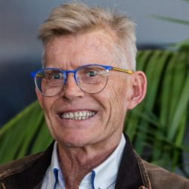

Steve Russell

DIRECTOR
Steve is a life long health consumer and an active health consumer advocate for over 40 years. His professional experience includes social justice and human resource program manager with the Commonwealth Government in the ACT, NSW and QLD, a community development consultant to all levels of government and community sector and an elected local government councilor.

He has held numerous positions as member and chair of Public Sector advisory and consultative committees on health and environment matters. He has been Chair of both Innisfail District Health Council and Cairns and Hinterland Hospital and Health Service Health Community Council. He is currently a Director of the Board of Far North Queensland Hospital Foundation.

He operates a small tourism business in Far North Queensland in partnership with his wife and is an aspiring recluse.

Why am I here?
As a long term health consumer I have been fortunate to be able to actively participate in the management of my particular health needs.

It became very obvious that not all health consumers are so fortunate and many have great difficulty navigating the health system. I am hopeful that through Health Consumers Queensland I can share my skills and experience to enable consumers to more actively manage their health needs and shape the health system.

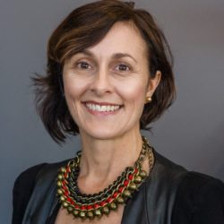

gabrielle quilliam

DIRECTOR
With a background as a Registered Nurse and Midwife, Gabrielle has worked as a social change agent in local, national and international healthcare settings that include emergency relief, community education and tertiary hospitals. Combining her clinical skills and experience as a foster carer, Gabrielle co-founded Hummingbird House as Queensland’s only children’s hospice.

Gabrielle has been a Director of Hummingbird House Foundation as well as a member of the Palliative Care Queensland State Committee and the Queensland Child and Youth Clinical Network. Her passion for authentic and comprehensive stakeholder engagement has resulted in human centred community based outcomes that reflect her advocacy skills in clinical, political, philanthropic and consumer sectors.

Why am I here?
I am passionate about identifying gaps in services that can be equipped through collaborative partnerships resulting in creative and sustainable solutions. I believe that when services connect with their consumers and understand their perspective, the best response can be delivered and the community becomes engaged and empowered. By working with Health Consumers Queensland, I hope to help people find the most effective pathways to be heard, understood, and enabled to be active participants in their health care.

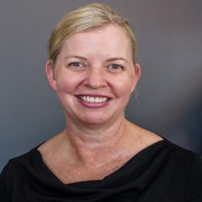

rachelle foreman

DIRECTOR
Rachelle Foreman is Health Director at the Heart Foundation in Queensland, is a Board Director of Health Consumers Queensland, Chairs the Community Board Advisory Group at Metro North Hospital and Health Service and is a member of Brisbane South Primary Health Network’s Community Advisory Council. She has undergraduate and postgraduate health and research qualifications from the University of Queensland. She chairs and sits on numerous strategic health committees, and has special interests in governance and strategy.

Rachelle has been an Investigator on numerous research projects in physical activity, health promotion and models of care – areas she is most passionate about.

OUR STAFF
We have a small, dynamic team with diverse experience across consumer representation, consumer engagement, health promotion, population health, public affairs, communications, community mental health and community development.

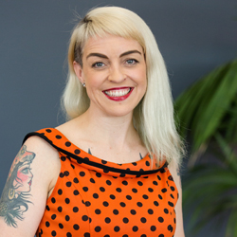

MELISSA FOX

Chief executive Officer
Melissa leads the organisation to support consumers and health providers to collaborate together to improve the safety and quality of health services. Melissa believes that consumers being involved in decision-making at all levels is essential to achieve consumer-centred care and to improve health services. She is a consumer representative on the Queensland Clinical Senate and the Nursing and Midwifery Executive Council and a board member of Consumers Health Forum (CHF).
Melissa has been a part of the journey of Health Consumers Queensland; she was an original member of the Ministerial Advisory Committee that later became the independent organisation that is now Health Consumers Queensland. Melissa is a mother of two gorgeous girls and has previously worked in documentary and reality television.
Why am I here?
Melissa first learnt the importance of individuals advocating for their health needs when she watched her grandparents confidently make choices around their own health needs after they each survived multiple heart attacks and strokes. After starting her own family, she devoted her time as a full time volunteer working on a systemic level to improve access to models providing continuity of midwifery care.
Melissa has seen first-hand from her own consumer representative roles, how valuable the partnerships between consumers and clinicians are in creating healthier people and communities. She is working towards consumers being recognised and valued as leaders in health decision-making for their own healthcare as well as at a policy and systems level.

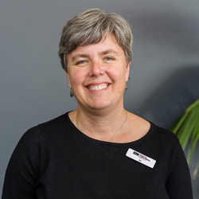

JO SMETHURST

senior engagement advisor
Jo is responsible for supporting consumers and consumer organisations so they can effectively partner with health providers and services. If you have an idea about how Health Consumers Queensland can support your work as a consumer representative give Jo a call.
Why am I here?
Jo loves the idea that health consumers can change the way in which we receive care by speaking up and becoming involved in decision-making about policies, services and health priorities. Being involved with a voluntary organisation that works towards improving maternity care for women across Australia helped Jo to see how consumers can be influential in re-designing and shaping our health care.

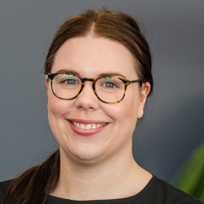

CHELSEA GOURGAUD

PROJECT OFFICER
Chelsea is responsible for supporting and maintaining relationships with a number of Hospital and Health Services and other organisations to support and increase effective partnerships with consumers and carers. This is done through a number of ways including, delivering trainings, facilitating workshops, providing strategic advice and specific project work including our Annual Forum. If you would like the opportunity to discuss consumer engagement and how you can embed this within your work, please contact Chelsea.

Why am I here?
Having engaged and worked with consumers and community members within a primary healthcare setting for a number of years, Chelsea understands the importance of partnering with consumers in shaping and improving the way health care is designed and delivered. Chelsea believes partnering with health consumers, carers and family members is a top priority in the decision making to improve health care and health services.

reema naresh

project officer
Reema is responsible for liaising and maintaining relationships with the Hospital and Health Services staff working in consumer and community engagement to support their effective partnering with consumers and carers. Reema’s role incorporates providing strategic advice, training and specific project work.

Why am I here?
Reema has worked extensively in community development as well as health promotion with culturally and linguistically diverse communities (CALD). She believes that to be engaged and involved in our own health decision making is essential to a person’s wellbeing. To understand our own physical and mental needs and to be able to articulate our health care needs, empowers a person to take control of their health. Having lived and worked in various countries she truly appreciates the wonderful health care system Queensland has to offer. Reema is passionate about supporting and skilling consumers, in particular CALD consumers and health care providers to be able to better engage with each other so that health consumers and their family’s needs are met.

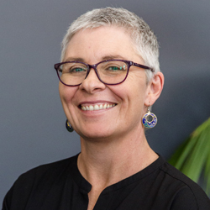

suzanne wirges

project officer
Suzanne’s role includes supporting skills development for consumers and health staff, providing strategic advice and training to Queensland Hospital and Health Services, and specific project work.

Why am I here?
Suzanne’s experience in health promotion showed her the difference true engagement can make to the lives of ordinary people, and the importance of equity of access to information. Growing up in a regional area, Suzanne is keenly aware of the potential the internet has for people outside of metropolitan areas to access information more easily, and enjoys using her web skills to make that happen.

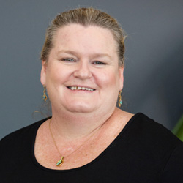

NICOLE O’KEANE

OFFICE MANAGER
Nicole is responsible for the day-to-day running of the office making sure our finances are impeccable and our consumer partners are reimbursed on time for their work with us.
Why am I here?
Nicole likes to use her administrative skills for organisations that make a social difference, particularly those who work towards equity for people who are sometimes overlooked or marginalised.

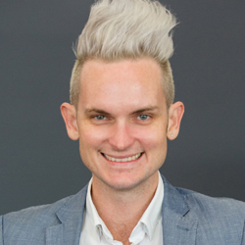

michael taylor

project support coorindator
Michael is our Project Support and Event Coordinator, that brings a little “zing” and a lot of “zest” into the organisation. Michael has been working in the wedding and events industry for the past 13 years. Most recently, he was employed with Metro North Hospital and Health Service in a variety of roles including Service Improvement with a focus on Standard 2 – Partnering with Consumers. Those who attended the recent Health Consumers Queensland Annual Forum will remember Michael by either being extremely tall or more commonly known as “the brother with the cool hair”.

Michael provides project support to our Project Team, works with Department on consumer recruitment as well as coordinates the communication with our networks.

Michael is always happy to have a chat or provide support to health service staff and consumers.

Why am I here?
Michael was originally hired as a contractor to assist in producing the annual forum. Throughout the contract, Michael demonstrated a commitment and passion to assisting consumers and health staff to better shape and co-design services being offered to Queenslanders.

Michael understands whilst there is still much work to be done in this space, incredible paths are being paved to providing a better health system to all Queensland patients. He also can’t wait to get started on our 2019 Annual Forum.

anne curtis

engagement consultant – special projects
Anne was our Project Manager and Senior Engagement Advisor for the past three years. Anne resigned from her full time position in May 2018 and has continued to work in a part-time capacity for Health Consumers Queensland on a consultancy basis on specific projects for Queensland Health and also fee-for-service projects.

Anne has been instrumental in building the profile of the organisation and many of the relationships that underpin much of our work today. Her consumer-focused, high level strategic advice on how to embed meaningful partnerships and the importance of health literacy has been much valued by the health organisations she has worked with.

Anne has over 28 years’ experience working in hospitals and health services in Australia and New Zealand, in senior communication, engagement, fundraising and project management roles. Anne has also managed a community engagement organisation in New Zealand focused on having the community’s voice heard in health planning and service delivery.

Why am I here?
I am passionate about the voice of consumers being heard and valued at all levels of health. This is why I continue to work part-time on projects that enable and encourage the voice of consumers in making significant change to how health services are designed and delivered.

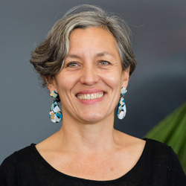

leonie sanderson

engagement advisor
Leonie Sanderson is the Health Consumers Queensland Engagement Advisor. Leonie has over 20 years of experience working in the consumer, engagement and community space and is looking forward to achieving positive outcomes on this significant project.

Why am I here?
Leonie believes that the best way to achieve real, lasting change in the health system is to enable people to be equal partners in their healthcare. Leonie’s advocacy began early when she staged a puppet show in Grade 3 to raise money for Deaf Children Australia. From working in Women’s Health to developing social policy to delivering community engagement projects, Leonie is committed to making sure the voice of consumers is heard and acted upon. She also loves strong black coffee and cannot resist an offer of chocolate.

HISTORY & ACHIEVEMENTS

2008:
Driven by the passion of many health consumers and carers and as a result of the Forster Review (the Dr Patel scandal at Bundaberg Hospital) Health Consumers Queensland was formed in 2008 as a 12-person Ministerial Advisory Committee – The Secretariat for the Committee sat within Queensland Health. Health Consumers Queensland developed a number of important documents and frameworks including:
- Consumer and community engagement framework
- Handbook for consumers
- Getting the Healthcare you need: An advocacy toolkit for people using the healthcare system in QLD
- Consumer and Community Engagement Resource Directory

December 2012:
The Queensland Government assisted Health Consumers Queensland to fund a business case to look at transitioning out of government.
COTA Queensland supported Health Consumers Queensland to continue our work by providing office space, administration and accounting support.

September 2013:
Health Consumers Queensland became a Non-Government Organisation (NGO) with a board, in line with the governance of our equivalents in other states.
Through a fee-for-service work, Health Consumers Queensland was able to continue its work.
July 2014:
Health Consumers Queensland joined together with COTA Queensland to host a Community Forum ‘When medical treatment is futile’. A joint Health Consumers Queensland/Queensland Clinical Senate meeting ‘All great stories need a good ending – clinician and consumer perspectives on end-of-life-care’ was then held resulting in a Charter for care of adult patients at the end of life’.
July 2015:
A service agreement was negotiated between the Queensland Department of health and Health Consumers Queensland. This enabled Health Consumers Queensland with three years of funding to continue to support and enable health consumers and carers to have a voice in how Queensland public health services are planned and delivered as well as advocating for health consumers and carers to be more involved in their health care decisions.
2017
Our Consumer and Community Engagement Framework for Health Organisations and Consumers was revised and published. The Second edition of the National Safety and Quality in Health Care Standards were released.

2018
Our new five-year funding contract commenced. We developed A Guide for Consumers: Partnering with Health Organisations published and A Guide for Health Staff: Partnering with Consumers. We developed our new Strategic Direction 2018–2023 which was launched to celebrate 10 years since our inception.

