Health Consumer Queensland - Consumer Advisory Group
Expression of Interest

Closing date
Close of business Monday, 17 December 2018
About us
Health Consumers Queensland is the peak organisation representing the interests of health consumers and carers in the state. We are committed to a health system that delivers quality and safe health services and values the voice of consumers in how health services are designed and delivered.
Our priority focus is on consumer engagement that influences and leads improvements and delivers better health outcomes for all Queenslanders. Health Consumers Queensland is a not-for-profit organisation and a registered health promotion charity and we believe in improving health outcomes for people in Queensland. One way we do this is through enabling consumers to be an effective voice in how health services are designed and delivered. Please refer to our Strategic Direction – What Guides our work.
Consumer Advisory Group
The establishment of the Consumer Advisory Group enables consumers and carers to partner with Health Consumers Queensland to inform the work it does, to ensure that it is a consumer driven and led organisation. Please refer to Appendix 1.
Purpose of the Consumer Advisory Group:
- To inform into specific projects, such as our Annual Forum, consumer networking sessions, consumer capacity building, future training content design and development.
- Identify opportunities for Health Consumers Queensland to further build the capacity of consumers and/or staff to strengthen future consumer partnerships.
- Identify emerging issues or trends in health that need to be addressed.

The secondary purpose is to develop, support and mentor current and emerging consumer leaders by:
- Mentoring of new and emerging health consumers and carers by experienced health consumer/carer representatives through membership of the Consumer Advisory Group.
- Providing Consumer Advisory Group members professional development opportunities to attend Health Consumers Queensland training sessions, attend health and engagement related conferences, forums and events, and be a speaker or presenter at a variety of conferences and forums.

Membership
- The Consumer Advisory Group will comprise 7 consumers and carers with lived experience of navigating the health system and varying degrees of experience representing consumers on health committees. This degree of experience may range from limited experience to many years’ experience. Break down of membership is as follows:
  - 1 Chairperson (2-year term)
  - 3 Experienced Consumer Representatives acting as a mentor to emerging consumer representative members with the guidance and input of the Chairperson (1-year term)
  - 3 Emerging Consumer Representatives with a desire to be mentored (2-year term)
- The Consumer Advisory Group will sit alongside other groups that provide input into the work of Health Consumers Queensland. (See Appendix 1).
- Terms of membership ranges between 1 to 2 years depending on the role (See Appendix 2).

Meetings
Meeting format
The committee will be a virtual working group with some face-to-face meetings and all other meetings will be conducted via teleconference or web meeting solutions. Some work will also be completed via email.
Frequency of meetings
There will be around 4-8 meetings per year.

Support and Secretariat
Support and secretariat services will be provided by two Health Consumers Queensland staff members (note taker and meeting facilitator). These staff members will not be members of the Consumer Advisory Group, but will provide support services only.

Support
Orientation and Training
Orientation will be provided to all Consumer Advisory Group members.

Consumer Advisory Group members will be offered training and support to fulfil their role. Professional development time will not be remunerated by Health Consumers Queensland.

Consumer Advisory Group members will be offered opportunities to attend conferences, forums and health related events. They will also have opportunities to present and speak from a consumer’s perspective.

Payment and Reimbursement
Consumer representatives will be reimbursed for their time and out of pocket expenses in accordance with Health Consumers Queensland Remuneration Policy. The Chairperson will be remunerated an additional 1 hour to cover meeting preparation, also in line with the Remuneration Policy.

Experience and qualities we are looking for:
- Lived experience as a health consumer or carer.
- Track record of good partnerships as a health consumer representative or a desire to develop good partnerships.
- Active in their community, with strong community networks.
- Have a sound understanding of local or regional health issues.
- Have a strong interest and passion for health system reform.
- Ability to identify and advise Health Consumers Queensland on priority areas and issues relating to consumer and community partnering/engagement.
- Raise significant issues and recommendations of a systemic nature, from a consumer perspective, to drive consumer led/co-design projects in health.
- Ability to make a long-term commitment (between 1 - 2 years depending on role).
- Bring issues and the voice of less heard health consumers. Demonstrated experience working with some of the following communities:
  - Aboriginal people
  - Torres Strait Islander people
  - From a non-English speaking background
  - Culturally or linguistically diverse
  - Lesbian, gay, bisexual, transgender, gender diverse or intersex
  - Children and youth
  - Living with a disability/chronic condition
  - Caring for someone with a disability
  - Physically isolated
  - Transport disadvantaged
  - Living in a rural or remote area
  - Living with a chronic illness including mental health

Recruitment process
- Consumers and carers from all regions of Queensland are encouraged to apply.
- You must be a member of Health Consumer Queensland’s Network to apply for membership to the Consumer Advisory Group.
- Some estimate times frames include:
We expect to conduct interviews on Wednesday 30th and/or Thursday 31st of January 2019. Applicants will be informed about the status of their application on Friday 1st of February 2019. Please note that a face-to-face orientation and meeting will be held on Tuesday 19th of February 2019.

How to apply
Please complete the Expression of Interest form on the following pages and return to Health Consumers Queensland via consumer@hcq.org.au by close of business Monday, 17 December 2018.
Here are some estimate time frames:
For queries relating to the Consumer Advisory Group or assistance completing this Expression of Interest, please contact Health Consumers Queensland via consumer@hcq.org.au or by phone on 07 3012 909

Expression of Interest form

Health Consumers Queensland - Consumer Advisory Group

Personal details
Full name:
Phone number:
Email:
Address:
Suburb: Postcode:
Would you like us to retain this application for future vacancies?  Applications not retained are destroyed once the application process is complete. |  |  | Yes | No
Are you a member of the Health Consumers Queensland network? If no, by completing this form you agree to join our network? |  |  | Yes | No
Would like to receive email updates from Health Consumers Queensland? |  |  | Yes | No
Gender
○ Male ○ Female ○ Intersex ○Transgender/gender diverse ○ Other ○ Prefer not to state
Age range
○ 16-24 ○ 25-29 ○ 30-39 ○ 40-49 ○ 50-59 ○ 60-69 ○70+
Please highlight any group that you identify as being a part of:
- Aboriginal people  - Torres Strait Islander people  - From a non-English speaking background*  - Culturally or linguistically diverse*  - Lesbian, gay, bisexual, gender diverse or intersex  - Children and youth. |  | - Living with a disability/chronic condition  - Caring for someone with a disability  - Physically isolated  - Transport disadvantaged  - Living in a rural or remote area  - Living with a chronic illness including mental health
* If you identify as being from a non-English speaking background, or culturally or linguistically diverse, please give details
Other needs and requirements

Is there anything that will help you participate in the Consumer Advisory Group better or more effectively? |  |  | Yes | No
If yes, please provide details e.g. disability support worker, interpreter, closed captioning, hearing loop, central position to enable better hearing, etc.

Please circle the role you are applying for:
Chairperson | Experienced consumer representative
 | Emerging consumer representative
Referees (someone who can discuss your consumer representative work – in the last 2 years) Please complete if possible.
Staff member of a health organisation or if not another organisation e.g. School P&C etc. | Health consumer or carer
Name | Name
Organisation | Organisation
Position | Position
Email | Email
Phone | Phone
Please limit your responses to experience relevant to the role you are applying for. Your responses to the following questions only need to be brief bullet points.

Please describe any experience as a health consumer representative including committees, focus groups, surveys, governance roles, etc.

Please describe any connections you have to your community (e.g. networks, groups)

How have you been involved with Health Consumers Queensland to date?
Options | Please tick
I have attended Health Consumers Queensland training
I have read/referred to Health Consumers Queensland resources (e.g. Consumer and Community Engagement Framework, eNews)
I access the Health Consumers Queensland website
I have applied for consumer/carer representative opportunities advertised through the Consumer Network
I have been selected as a consumer/carer representative as a part of a Health Consumers Queensland selection process
I have participated in a workshop/focus group facilitated by Health Consumers Queensland
I attended the Health Consumers Queensland Annual Forum
I presented at the Health Consumers Queensland Annual Forum
I attended a Health Consumers Queensland networking session
Any other way not listed above, please give details:

Please describe what value you would bring to the Health Consumers Queensland’s Consumer Advisory Group?

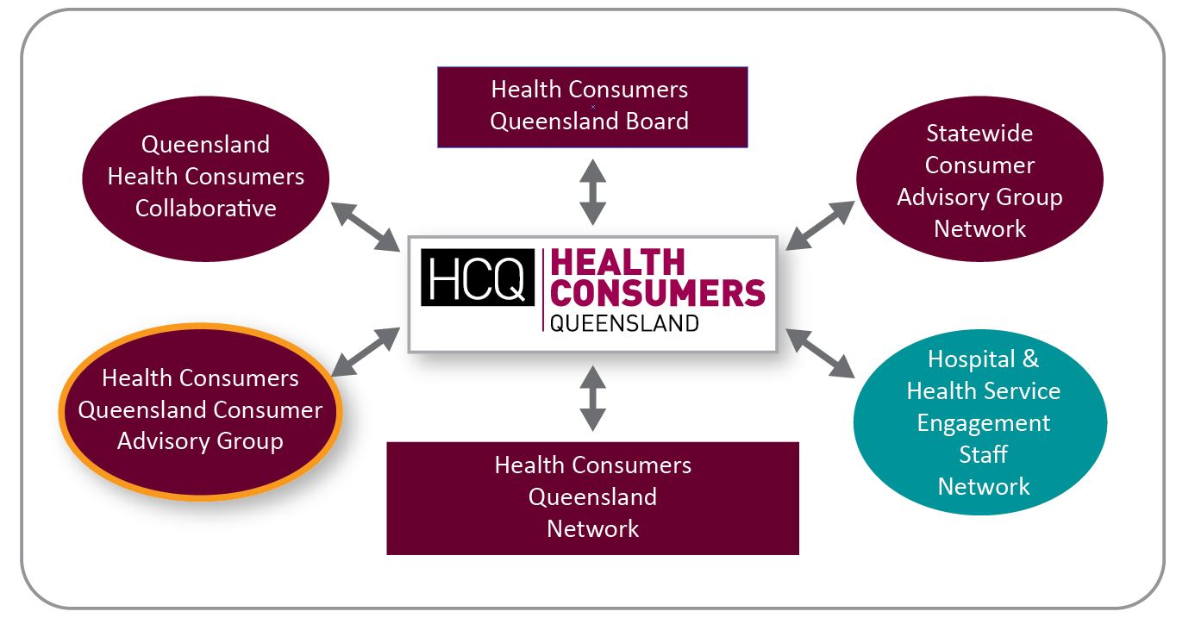
Appendix 1
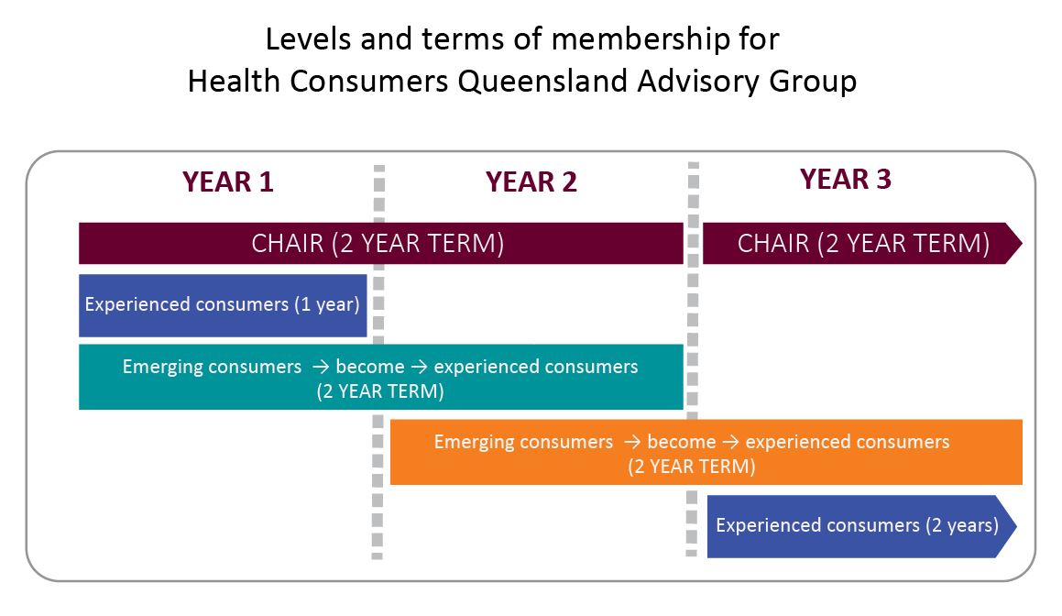
Appendix 2
Appendix 3
All members are expected to actively participate in the Health Consumers Queensland’s Consumer Advisory Group and bring a consumer perspective to all discussions and decision-making. Each role has a different requirement in terms of abilities and experience. Listed below are some examples of these variations, which may help you in writing your application.
Role | Some key responsibilities | Experience
Chairperson | - Chairs meetings  - Supports and mentors experienced consumers in Consumer Advisory Group  - Helps draft terms of reference for membership  - Ability to commit for a 2-year term | - Extensive experience as a health consumer representative on state-wide and national health issues as a consumer representative  - Previous experience as Chair of a Consumer Advisory Group, Consumer Advisory Network, or consumer-based organisation related to health or consumer and community engagement  - Previous experience mentoring or supporting other health consumer representatives  - Possesses a thorough understanding of matters that affect people receiving healthcare in the State of Queensland  - Excellent understanding of the Health Consumers Queensland Consumer and Community Engagement Framework.
Experienced Consumer Representative | - Mentors and provides support to Emerging Consumer Representative members of the Advisory Group  - Helps draft terms of reference for membership  - Ability to commit for a 1-year term | - Demonstrated experience in health system reform through consumer representative roles  - Experience mentoring or supporting other health consumer representatives  - Possesses a good understanding of matters that affect people receiving healthcare in the State of Queensland  - Good understanding of the Health Consumers Queensland Consumer and Community Engagement Framework.
Emerging Consumer Representative | - Helps draft terms of reference for membership  - Ability to step into an Experienced Consumer Representative role after their first year of term  - Ability to commit for a 2-year term | - Lived experience as a health consumer  - An interest in health system reform  - Possesses a basic understanding of matters that affect people receiving healthcare in the State of Queensland  - Some understanding of the Health Consumers Queensland Consumer and Community Engagement Framework.

