Queensland Health
Queensland Paediatric Quality Council (QPQC)
Application for Steering Committee Members
Closing Date: COB Thursday November 21st
The Queensland Paediatric Quality Council is looking for two (2) consumer representatives to be part of the QPQC Steering Committee.

We are seeking expressions of interest from:
- consumers who have experience as a parent/carer/consumer of Queensland Health paediatric services, and
- have an interest/passion in patient quality and safety and preventative health services

The Queensland Paediatric Quality Council is an approved Quality Assurance Committee (QAC) which operates within the Clinical Excellence Queensland division of Queensland Health. It also partners with Children’s Health Queensland Hospital and Health Service. Its purpose is to:
- collect and analyse clinical information regarding paediatric mortality and morbidity in Queensland to identify statewide and facility-specific trends;
- make recommendations to the Deputy Director General on standards and quality indicators of paediatric clinical care;
- contribute to state wide initiatives and develop strong ongoing partnerships with a variety of stakeholders including clinical networks and other quality assurance councils
- enable health providers in Queensland to improve safety and quality; and assist with the adoption of such standards in both public and private sectors

Steering Committee Purpose
The QPQC Steering Committee is a multidisciplinary group which provides leadership, future planning and strategic governance for the QPQC. The QPQC’s current areas of work include the priority areas of Infant Mortality and Clinical Incidents.
The major activities of the QPQC Steering Committee include:
- Providing strategic direction and endorsement for the work of the QPQC and its 2 subcommittees (the Infant Mortality Subcommittee and the Clinical Incident Subcommittee);
- Oversight of subcommittee projects;
- Monitoring the QPQC budget and supporting grant applications;
- Advocating for the work of the QPQC and its subcommittees and providing linkages with other stakeholders as required;
- Oversight of research, ethics, data and integrity;
- Responding to and actioning QPQC related correspondence.

For more information about the QPQC including our Terms of Reference see https://www.childrens.health.qld.gov.au/chq/health-professionals/qpqc/
Role of the Consumer
The role of the consumers on the QPQC Steering Committee is to:
- Actively participate in steering committee discussions and meetings
- Confidently advocate on behalf of health consumers and carers
- Bring a consumer/carer perspective to all discussions and decision-making
- Review meeting papers in advance and response to out of session business via email
- Contribute to the co-design of activities to review and improve the experience of families using state wide paediatric health services
- Provide feedback from a parent/carer’s perspective on materials, resources and reports destined for families and/or clinicians and health professionals
- Promote the activities and functions of the QPQC and provide linkages with other potential strategic partners
- Provide strategic direction and governance on the scope of work of the QPQC and its subcommittees and look for future opportunities and improvements in relation to paediatric patient safety and prevention

All members on the QPQC represent and bring skills and knowledge relating to their areas of expertise, such as consumers and carers, clinical professions, service types or statewide work units.
Confidentiality
The QPQC is a privileged committee under the Hospital and Health Boards Act 2011 (HHBA). Members are required to sign confidentiality agreements and to maintain confidentiality of discussions, meeting materials and business of the committee. These strengthened confidentiality requirements are outlined under the HHBA and are a standard requirement of any Quality Assurance Committee.
Who is it for?
This opportunity would suit a consumer/carer/parent representative:
- With at least 12 + months experience sitting on a committee at the HHS, or Statewide level
- Has an understanding of the Queensland Health system and experiencing providing consumer feedback
- Has experience in health as a patient, parent or carer
- With a high level of literacy including reading, writing and communication
- Has a strong commitment and passion in patient quality and safety and preventative health services
- Has a good understanding of the future of healthcare from a consumer or carer perspective
- The ability to think and act strategically with the ability to understand and contribute to the strategic direction of the QPQC
- The ability to articulate a consumer perspective in a positive and respectful way and appreciate different perspectives expressed within the committee
- We encourage those who identify as Aboriginal or Torres Strait Islander, culturally or linguistically diverse or from a rural and remote area to apply, to support the diversity of experience of the council
Time and location
The average time commitment is:
- 1.5-hour meeting commencing at 2pm, generally held every 3-4 months per year on a Tuesday afternoon at the Centre for Children’s Health Research (CCHR) 62 Graham Street South Brisbane
- Between 2 and 3 hours per quarter of pre-reading, preparation and feedback out of session
- Members unable to attend in person can attend via videoconference or teleconference
- QPQC steering committee consumer appointments are for a 2-year period
Remuneration and Support
The successful consumer/or carer will be reimbursed for their time at the meeting as per Health Consumers Queensland’s guidelines, details below:
• $187 for meetings 4 hours and under (including pre-reading and travel time)
• $374 per meeting over 4 hours (including pre-reading and travel time)

The consumer/or carer will also be reimbursed for any travel or parking expense with an original receipt and tax invoice raised if attending in person.

For consumers based outside of Brisbane in regional, rural or remote locations, travel support may be negotiated to attend an initial meeting in person, to develop a face to face rapport with the QPQC steering committee. Videoconferencing and Teleconferencing facilities are also available for ongoing meetings.

The QPQC steering committee secretariat will provide orientation and ongoing support for the successful consumer’s representative, including pre- and post-meeting briefings.

How to apply
Please complete the below consumer application form and return to QPQC@health.qld.gov.au by COB Thursday November 21st 2019.

For assistance please contact Jayde Archer at QPQC@health.qld.gov.au or (07) 3069 7810
QPQC Organisational Chart
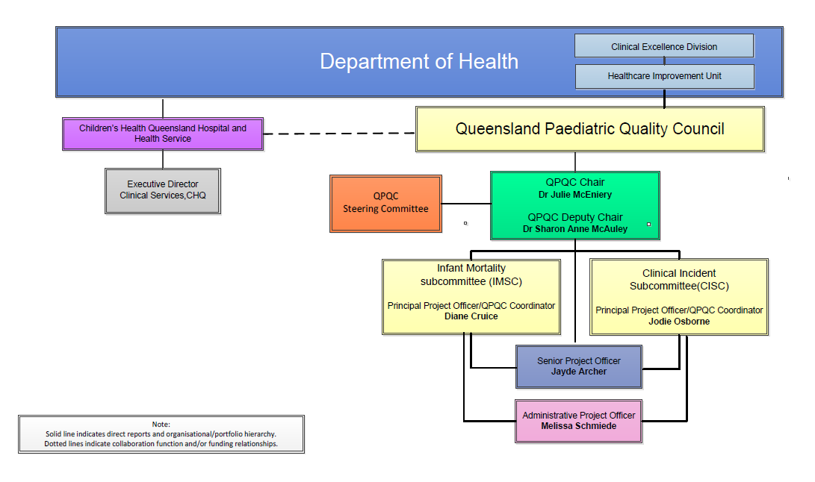
Consumer Application Form
Queensland Paediatric Quality Council Steering Committee
Full name:
Preferred phone number:
Email:
Postal address:
Postcode:

- I would like to receive email updates from Health Consumers Queensland YES | NO
- Are you happy for Queensland Health to share this form with other members of Queensland Health as part of the process for this application? YES | NO

Please highlight any group you identify as being a part of:

- Living with a disability/chronic condition
- Caring for someone with a disability
- Physically isolated or transport disadvantaged
- Culturally or linguistically diverse
- From a non-English speaking background

Do you identify as: Aboriginal | Torres Strait Islander | Both | Prefer not to state
Are you a: Consumer | Carer

Age range: 16-24 25-29 30-39 40-49 50-59 60-69 70+

Please describe any support you need to take part in this activity (examples include support person, hearing loop, dietary requirements)

Your responses to the following questions only need to be a brief sentence or two
1. Please list experiences or connections you or your child/children have had with Queensland Health service providers specialising in paediatrics
Tip: Think about how this relates to the role you’re applying for

2. Please describe your experience as a health consumer representative including committees, focus groups, surveys, governance roles, etc. Describe some of your achievements/wins you made?
Tip: Past consumer representative positions that have similar requirements to the opportunity you’re expressing interest in. Give an indication of how long each position was for, and any relevant highlights.

3. Please describe your interest in this topic and how you think you can make a difference being involved?
Tip: Although this section usually requires the longest response, try to keep it concise. Things to consider focusing on here include:
- any past lived experience that shows your understanding of the topic, or
- your understanding of the social/health/economic implications of the topic/condition, or
- Any systems change that you have identified that will improve care for health consumers, and possible strategies you could share to affect that change.

Please provide contact details for a staff member from a Hospital and Health service or Department of Health, or other health organisation you are currently partnering with. (We will advise you before we contact your referee).

Full name:
Staff Role:
Partnering Activity (e.g. Committee Chair):
Organisation:
Phone number:
Email:
Applicant Role:

